Salford Mental Health Online Forum Minutes
Wednesday 26th August at 12.00 - 2.30pm

Attendees: Dan Stears (Chair), Vania Burnell (Deputy Chair), Yunus Mogra, Noami Evans, Dennis Baldwin, Curly Rob, Sarah Buckley, Caroline Allport, Jayne Gosnall, Margaret Mary, Chris Ogden, Rachel Bates, Simone Walker, J Ahmed, Rob Hemmingway, Michelle Dennett, Maurine Burke, Emma Hinchcliffe.

12.00pm – Introductions and Updates

Welcome back and to our new members.

The Big Reset Conversation will be launching on 7th September so you will be able to help Salford CCG build back better services reopening. There will be the opportunity to take part in online surveys, one to one interviews and focus groups. If you would like to be involved please get in touch with Caroline Allport by telephone on 07841685639 or email to caroline.allport@nhs.net; or visit their website and Caroline’s Facebook.

Salford Suicide Day – email dennisb@startinspiringminds.org.uk for details of how to get involved. There is a flier at the bottom of the minutes with more information.

12.10pm – Living Well Update
You can read Chris’s presentation in the information section.

Chris Ogden (Programme Manager at Salford CCG) presented on Living Well which is a mental health transformation programme with the Innovation Unit as part of a network of four national sites based on model that was implemented in Lambeth. There has been a focus on people’s experiences and codesign. Their vision for Salford is that we will have an open and informal front door which focusses on services and support being integrated so that service users have access to everything they need in one place using a holistic approach including health, social care, and VSCE organisations.

Some of this work was paused when Covid-19 closed services but Beyond was launched to ensure people had access to mental health support during the lockdown period. This is funded until July 2021 and there are plans to incorporate what we have learnt about providing high quality digital support to mental health service users into the Living Well service design. Living Well are working with 20 people in Broughton and will be rolling this out later this year; and the Beyond service had had 250 referrals since July 2020.

VSCE grants of up to £70k have been launched focusing on loss, substance misuse, family and carers over an 18 month period until March 2022. You can find more details of this on Salford CVS’ website: https://www.salfordcvs.co.uk/live-grants

Feedback from the members:
- The feedback from people who are already accessing the new support has been fantastic. The holistic support is already support people in their onward journey.
- There is a huge opportunity for SMHF to link into this to ensure that service users have continued contact and support from their peers.
- This sounds like everything I have ever hoped for. I would like to speak to you about Self Reliant Groups at some point as part of the recovery journey.
- Digital solutions have been key and there is a real opportunity to utilise how people are accessing connection now.

12.40pm NWAS

Yunus Mogra and Rachel Bates (Patient Engagement Leads at NWAS) gave a presentation and asked members to share their views of using the ambulance service at this time. Initially during the pandemic, we were doing a lot of signposting through NHS111, which rose from 4,000 to 15,000 per day in calls and many more looking online for information but there was a drop in the use of paramedic services. This has now reversed as clinics start to open again but some has been down to the weather or people’s mental wellbeing after being in an extended period of lockdown. There have been 160 volunteers recruited and trained during this period who were medical students, retired ex-NHS staff and people who had left the sector, who have been supporting people during the lockdown which we are hoping to continue.

Feedback from the members:
- I went in myself after contracting the symptoms of Covid-19 but a few days later it got worse, so we went through NHS111. The NHS ambulance responders turned up in their PPE and they gave us lots of advice about care and home distancing.
- Before the pandemic, over the years, they have responded to me in times when I’ve been unwell or to suicide attempts. They have always been really helpful and I’ve been happy with support I’ve received.
- A friend of mine called me yesterday about their father falling earlier this week. His paid carer had been there after he had a minor fall. They came out and left without any further action. However, this has triggered a social care referral which was unnecessary.
  - Yunus noted this and said that the council will be wanting to refer this man to the Falls Prevention Team to reduce the frequency at which the falls are happening. These referrals are often made because family carers are unlikely to ask for help and to check if there is more support needed.
  - GMMH have a group called ‘hidden carers’ because they don’t recognise their carer role because they are related in some way so feel that it is their obligation to provide care and support.
- One member asked about how staff were being supported during this period to ensure any abuse they experience or trauma within the field does not impact on their wellbeing.
  - Simone added that a Staff Wellbeing Policy has been implemented for staff that are in the calls center or out in the community seeing trauma and suicide. There is an app online for mental health; alongside videos on exercise, mindfulness and diet; assessments for staff after difficult visits to patients. We also have senior staff trained to debrief and support staff ongoing.
- There has been an increase in the use of taxis which are being relied on more because the social distancing means NWAS cannot fit as many people in the ambulance vehicles for non-emergency transport. However, there is an assessment for the use of transport which consider medical conditions and mobility: https://www.nwas.nhs.uk/services/patient-transport-service-pts/eligibility
- The majority of forum members have been using the Gov, CCG, and Council websites. There are also alerts on Facebook from PHE. However, many people will just google so having ads and your information high up on the search list.
- There is a concern that people who aren’t online won’t be able to access this information so seeing how you can link up to other services. I registered my mum for support online and the response was quick but not everyone has someone to link them in. Once they are known it works fantastically but ensuring they are in touch is essential. There are also people who aren’t connected but are doing mutual aid for their neighbours but there are also those who are completely alone.
- Some members said they would use the ambulance service if they really needed to but many would feel anxious about going to hospital or wouldn’t want to use the service unnecessarily because of the current pressure on the NHS. People shouldn’t be using an ambulance unless they needed to but they have a huge amount of confidence in the service so would always call for a family members, neighbour or a friend.
- On visiting a hospital the feedback was that people would ensure that they were following social distancing guidelines that are in place.
- It would be useful to have links with the police and mental health services to ensure that when people need to be taken to a place of safety or support with a mental health crisis to ensure the team responding have the right skills.
- Members had a discussion about how inclined people will be to go for a flu jab this year and encouraging people with good information and easy ways to have it.

NWAS are inviting people to share experiences: If you would like to share an experience with NWAS please get in touch with yunus.mogra@nwas.nhs.uk.

14.15pm – Any Other Business

Salford Mental Health Forum – we are exploring some project ideas identified by members at the stakeholder day last May and that members have said would be useful during this period that we will update on over the coming months.

DATE OF NEXT FORUM MEETINGS – last Wednesday each month from 12.00 – 2.00pm
- 30th September
CLICK HERE TO DOWNLOAD THEM INTO YOUR CALENDAR

- 28th October
- 25th November

Join online via this link https://zoom.us/j/98952862430 or call in by UK telephone on +44 208 080 6592

Resources and Information Sharing

Suicide Prevention Day Vigil
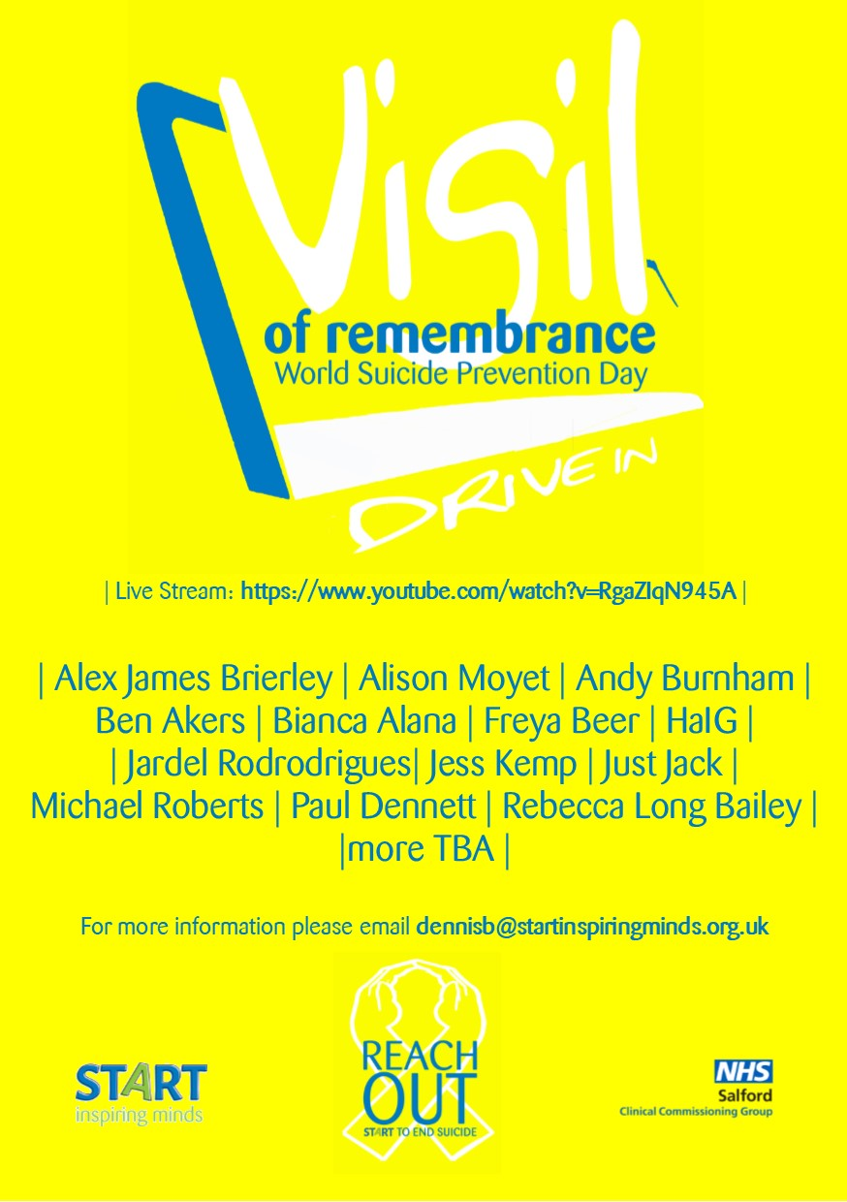
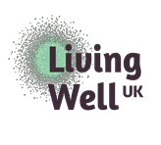
Salford Living Well Programme Update to Salford MH Forum – 26 August 2020
Chris Ogden – Programme Manager
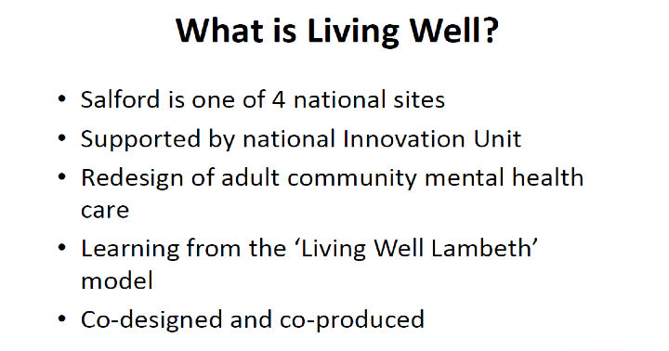
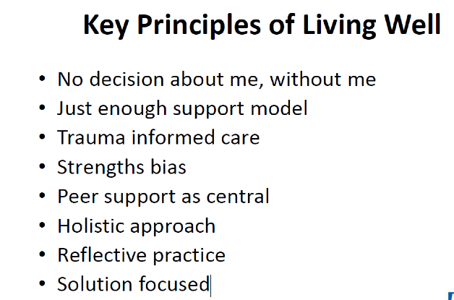

Living Well Salford – Target Groups

Target Groups are Working Age Adults who:
● Fall through the gaps between services e.g. those referred from primary care but who don’t meet the criteria for secondary care services.
● May be assessed by the Liaison service but do not need further intervention from the CMHT
● Could be supported to step down from the CMHT with further support

People from the above cohorts may experience:
● Complex social care needs, including those living unstable, chaotic lives (eg drugs, alcohol, homelessness)
● Long term physical health conditions and mental health conditions
● Domestic violence and be in contact with services (eg MASH, Police)
● Transition to adult services (LAC?)
● Caring Roles
● Isolation, including adults living alone and older adults post bereavement
● PTSD e.g. Refugee and Asylum Seekers
● Reluctance to access mental health support due to stigma or lack of recognition of mental health e.g. the Jewish community, BME communities... but not those in immediate crisis or exhibiting very high risk.

Engagement & Design Process
The Process: Engagement

Ethnographic Research
- The study of people and cultures. Designed to understand the world from the perspective of the participants
- ‘Walking alongside’ someone vs simply asking about their experiences
- Allows observation of people’s lives to understand their strengths,
resilience, contacts, challenges, aspirations
- Range of people trained in ethnographic approaches
- 8 journeys gathered initially – depth of insights vs number of stories
- Incredibly powerful way of presenting a case for doing something differently

Engagement: Insights
• Key insights:
• Trauma and Adverse Childhood Experiences
• Resilience
• Aspirations
• Loss
• Wanting to be heard / be listened to / believed
• Clear about own needs and when help is needed
• Understanding what makes a good / bad system from the perspective of someone with lived experience?

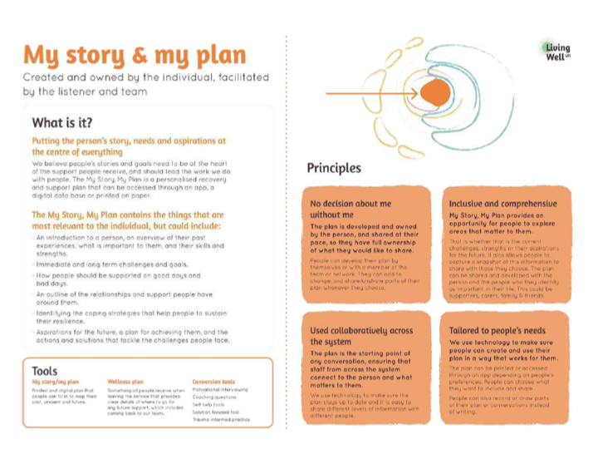
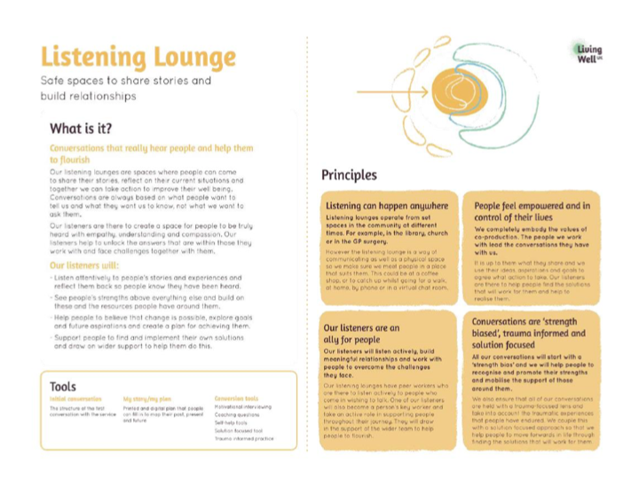

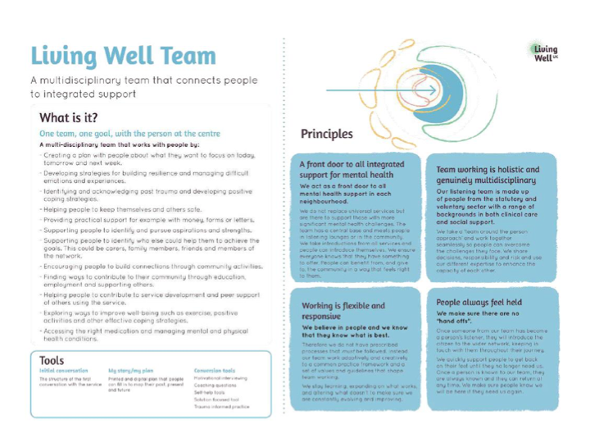
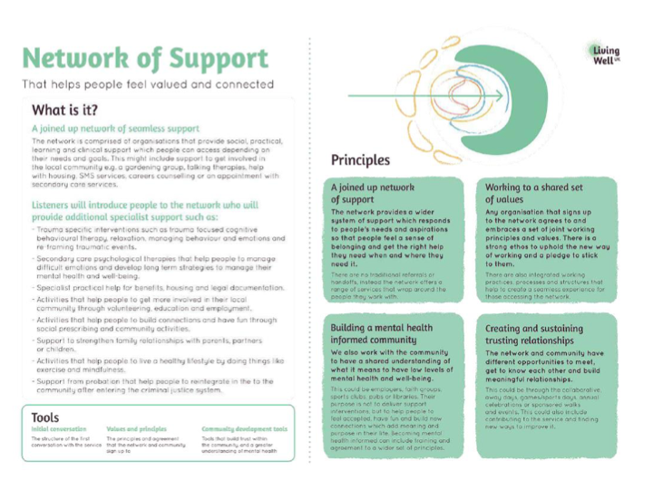
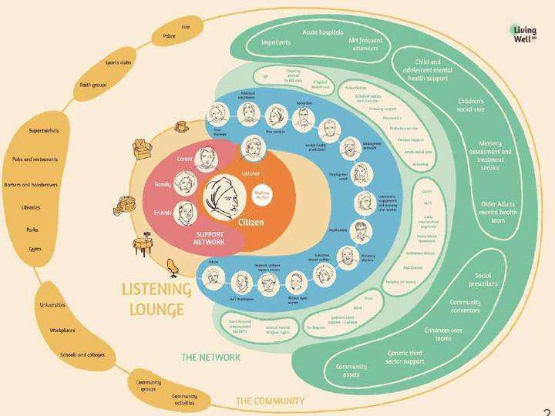

Early Implementation
- Testing in Broughton
- Core team in place (Operations Manager; Recovery Worker; 2 Peer Workers; Occupational Therapist)
- Began working with a small group of people......COVID-19 forced us to pause the programme

Beyond
- Living Well was paused during the immediate response to COVID.
- Spirit of Salford line was established by the Council to support those who were isolating / shielding due to COVID and directed people through to get support around food parcels, housing, debt advice etc.
- People known to GMMH were referred to the 24/7 GMMH support line.
- There was a gap identified for people not known to MH services but needing support.
- The development of a VCSE Collaborative (Beyond) was put in place to provide a city wide Mental Health offer to people not known to Greater Manchester Mental Health Foundation Trust (GMMH)

Beyond – Functions and Future Vision

The functions of Beyond are as follows:
- Support to access online offers e.g. mindfulness sessions, computerised CBT etc
- Support to develop / adapt / engage in activities to support wellbeing and mental health e.g. using Start’s Wellbeing Hub
- Short term problem solving approaches
- Holding / stabilising / liaison re crisis prevention

Our Future Vision for Beyond:
- Funded until July 2021
- Between now and then, we will work to integrate the Beyond service into our wider Living Well offer

Now and Plans for the Future

Growing The Team
- 1 x Team Manager / MH Clinician
- 1 x MH Clinician
- 2 x Peer Supporters
- 1 x Occupational Therapist
- 2.7 Recovery Workers (including employment support)
- 1x PA Consultant Psychiatrist
- We have also commissioned Mind in Salford and the Salford Mental Health Forum to work together on building / training /supporting peer workers and peer volunteers throughout the programme.
- In the process of recruiting an engagement worker; social worker; volunteer co- ordinator; and team administrator.

Living Well Team:
- Will continue the original testing approach in Broughton;
- Currently working with 20 people;
- Looking to gradually increase coverage – aiming for full coverage in Broughton
neighbourhood by end of October;
- Will continue to grow the team in order to support roll out in at least one other
neighbourhood by March 2021
Beyond:
- Have received over 250 referrals since July;
- Number of referrals has dropped recently; but we’re seeing a higher proportion of
complex referrals
- Plan is to integrate both offers by July 2021

Other Developments:

VCSE Grants:
• We have identified 3 priorities for our VCSE grants for the current round:
- Substance Misuse
- Family and Carers
- For each of the above themes one grant of up to £70k will be awarded for 18month projects (activity up to March 2022)

Developing Links with IAPT and Psychological Therapies:
• Recent discussions have taken place with local IAPT and Psychological Therapy partners to consider the part IAPT has to play in supporting the Living Well Team and wider Living Well system.

Developing our approach to trauma savvy care:
- How do we make the theory a reality in practice?
- Training Opportunities

